**BPA Replacement Chemical**

**Business Plan**

**By:**

**Ryan Lally, XIA MIN, Krin Yongvongphaiboon, Shruthi Kathare, Shriya Desai**

**TABLE OF CONTENTS:**

1. **Executive Summary**
2. **Introduction**
3. **Idea ( technology/project) description**
4. **Markets and customers**
5. **Competition and Trends**
6. **SWOT Analysis**
7. **Specific Strategies, Plans and Actions**

* **Customer Relationship**
* **Distribution and Channels**
* **Key Partners**
* **Key Activities**
* **Key Resources**

1. **Revenue and Cost Structure**

* **Revenue**
* **Cost Structure**

**9. Conclusion and Recommendations**

**Executive Summary**

Bisphenol A (BPA) is a molecular building block that was discovered in 1891, but wasn’t commonly used until polycarbonates were invented in 1953, in which BPA is a main ingredient. Due to the growth in popularity of polycarbonates, which are used in everything from automobiles to water bottles, BPA quickly grew in popularity as well. United States production of BPA grew from 16 million pounds in 1991 to approximately 2 billion pounds in 2004, and thus became one of the most produced chemicals in the world. It’s popularity does not come without a price, however: BPA is dangerous to both human health and the environment. Since the FDA’s ban on BPA in baby products in 2012, there have been a number of BPA replacement chemicals, many of which have been found to be as or more harmful to human health than BPA itself.

Professor Daniel Schmidt of the University of Massachusetts in Lowell has discovered a BPA replacement chemical that is safe for human health and the environment, we have designed a business plan to sell the chemical to the global polycarbonate market, with a focus in the plastic water bottle industry. This market is very large, accounting for $14.6 billion in sales in 2014, and is expected to grow larger. There is competition that we will have to face in this market due to other BPA replacement chemicals, which are harmful to human health yet have already been implemented in plastic bottles from large corporations such as Coca-Cola and Pepsico, two companies we hope to sell our chemical to.

Our product has the key advantage over our competition of being safe for humans of all ages and the environment. We are still new to the market, so we must first establish ourselves with a well-tested chemical and proof of our claims. Once we establish ourselves, however, we intend to market our chemical to plastic bottle manufacturers primarily through direct marketing, and maintain strong customer relationships to keep profits up and eventually dominate the market. Of course, we have many costs we must cover before we are able market our product to major corporations, so we plan to team up with investors so we can meet our expenses and manufacture our chemical in bulk.

The total market for BPA is huge, and we expect that our chemical will dominate approximately 80% of that market in the future with our safe replacement chemical. Our hopes is that, with this business plan as our map, we will be able to overtake BPA and it’s replacement chemicals in plastic drinking bottles in the near future. This would be a major achievement and would increase the health and safety of people of all ages all over the world, and for generations to come.

**INTRODUCTION**

Bisphenol A (BPA) is an organic synthetic compound with the chemical formula (CH3)2C(C6H4OH)2 belonging to the group of diphenylmethane derivatives and bisphenols, with two hydroxyphenyl groups. It is a colorless solid that is soluble in organic solvents, but poorly soluble in water. Bisphenol A was discovered in 1891 by Russian chemist Aleksandr Dianin. Based on research by chemists at Bayer and General Electric, BPA has been used since the 1950s to harden polycarbonate plastics, and make epoxy resin, which is contained in the lining of food and beverage containers

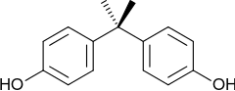

Bisphenol A is a polycarbonate employed to make certain plastics and epoxy resins. it contains a hormone disruptor, this chemical can leach out when it is heated or exposed to acidic solutions. It is very common in plastic water bottles. Some of the plastics can be eco-friendly and may be safe, other contain harmful chemicals or cause dangerous pollution during the manufacturing and the plastic contain harmful synthetic estrogen.

Polycarbonate plastics have many applications including use in some food and drink packaging, e.g., water and infant bottles, compact discs, impact-resistant safety equipment, and medical devices. Epoxy resins are used as lacquers to coat metal products such as food cans, bottle tops, and water supply pipes. Some dental sealants and composites may also contribute to BPA exposure. BPA polycarbonate possesses a unique combination of toughness, optical clarity and high heat resistance, and is therefore used in a wide variety of common products including digital media, electrical and electronic equipment, automobiles, sports safety equipment, reusable food and drink containers, and many other products.

Numerous studies have indicated a wide array of possible adverse effects from low-level exposure to Bisphenol A: Chromosome damage in female ovaries, decreased sperm production in males, early onset of puberty, various behavioral changes, altered immune function, and sex reversal in frogs, estrogenicity, endocrine disruptor and so on. It is not only toxic to adults and children it is toxic to even the unborn due to ubiquity of canned foods.

Prof. Daniel Schmidt at UMass Lowell has identified a substitute for BPA in epoxy resins and has successfully synthesized alternative epoxy resins (diglycidyl ethers and higher molecular weight epoxies) based on this compound and demonstrated that it can form a network with similar properties to the equivalent BPA‐based material.

**Idea (technology/project) Description**

BPA is a chemical that has been used to harden plastics for more than 40 years. It's everywhere. It's in medical devices, compact discs, dental sealants, water bottles, the lining of canned foods and drinks, and many other products. So what does BPA do to us? According to research from U.S. Food and Drug Administration (FDA) mentioned that BPA could potentially effect on our brain, behavior, and prostate glands in fetuses, infants, and young children. As a result, it can cause reproductive disorders, heart disease, and breast cancer.

BPA not just damage our bodies but also harmful for the environment. BPA is used in the production of epoxy resins, polycarbonate resins, and polyester resins. It is water soluble, so a likely source for environmental release of the chemical is wastewater from polycarbonate and epoxy manufacturing plants. It is also likely being released into the air as well. Prof. Daniel Schmidt at UMass Lowell has identified a substitute for BPA in epoxy resins and has successfully synthesized alternative epoxy resins (diglycidyl ethers and higher molecular weight epoxies) based on this compound and demonstrated that it can form a network with similar properties to the equivalent BPA‐based material. This approach relies on commercially available, economically viable monomers with no structural similarity to estrogen.

So what are we trying to achieve? Our BPA substitution that used in plastic bottles will not cause any health effect to human body. Unlike BPA, our substance does not contain polycarbonate which mean it is reusable and eco-friendly for our environment. In terms of the price, our product will cost the same as the current market price for BPA.

Our BPA substitute can be used in variety of products: Automobile sector, installation of wires, helmet manufacturers, discs and DVD’s, medical purpose (in incubators), sports safety equipment, phone and laptop’s screen, eyewear, and store receipts. To pursue additional application, Sports safety equipment manufacturers, automobile, and installation of wire. For sports safety equipment, there are 86 bike helmet manufacturers in the United States. These companies spend an estimated $700-$1,400 per ton on polycarbonate for polycarbonate helmets. BPA is excellent electrical resistance. Because of these attributes, polycarbonate is used in a wide variety of common products including digital media (e.g., CDs, DVDs), electrical and electronic equipment, automobiles, sports safety equipment, reusable food and drink containers, and many other products.

**Markets and Customers**

We will focus on plastic bottles. Pepsico, coca-cola are the two examples we are focusing on as they are the biggest producers of plastic bottles globally. It is estimated that companies such as these spend between $700-$1,400 per ton. Many of their products uses polycarbonate, which contains BPA. Our substitute will replace that BPA without affecting the quality of the product or the costs to the manufacturer's.

We found the information from the following links:

~50 Billion plastic bottles were made last year.

(source link: http://www.treehugger.com/clean-water/the-us-consumes-1500-plastic-water-bottles-every-second-a-fact-by-watershed.html).

~8 Billion pounds of BPA made last year.

(source link 1:http://www.ncbi.nlm.nih.gov/pmc/articles/PMC2774166/).

(source link 2: <https://books.google.co.in/books?id=G3xHBAAAQBAJ&pg=PA2&lpg=PA2&dq=~8+Billion+pounds+of+BPA+made+last+year.&source=bl&ots=fQuDni8-IQ&sig=OJL35QCrZwt6jSPZ5Gwu0_bU_MU&hl=en&sa=X&ved=0ahUKEwjg68Hq95nKAhUCC44KHanTDVMQ6AEIKTAC#v=onepage&q=~8%20Billion%20pounds%20of%20BPA%20made%20last%20year.&f=false>).

The BPA market is very large, accounting for $14.6 billion in sales in 2014. 8 Billion pounds of BPA is manufactured every year. The BPA-free market is relatively small and would be effectively easy to enter if our product is not a health hazard like other BPA-free chemicals. We would start by selling our chemical at the same price as BPA when we enter the market. Bellow is a table illustrating the global production capacities of bioplastics:

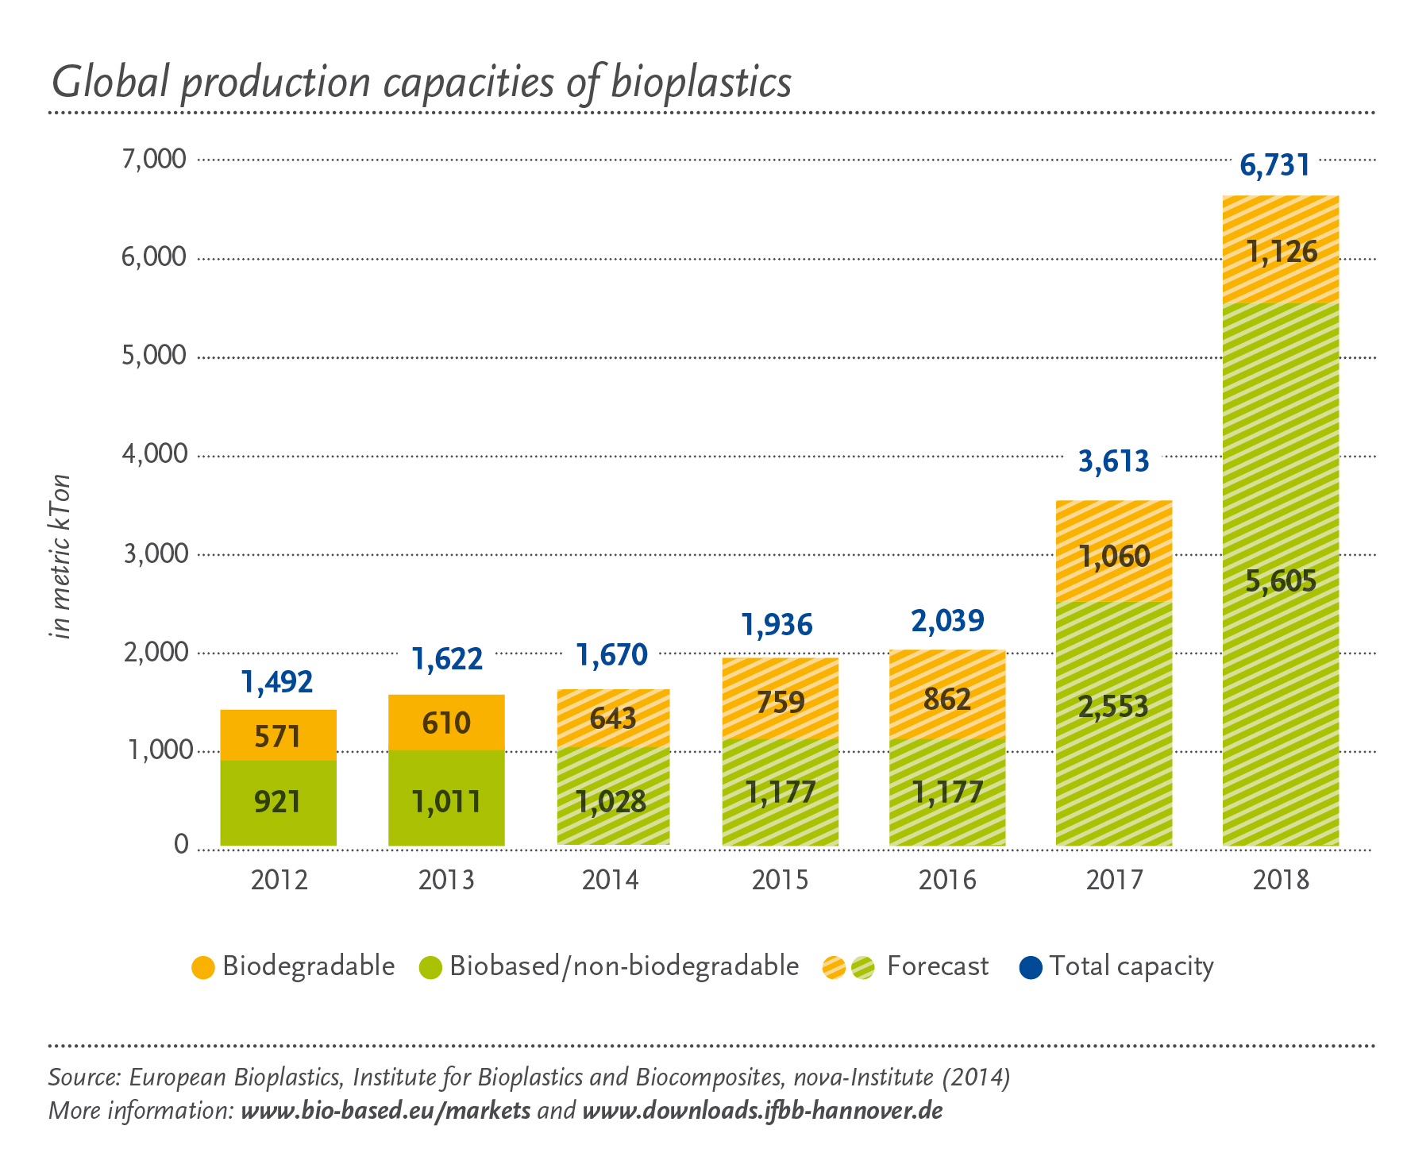

The global BPA market is expected to grow by 5.2% annually, reaching $21.9 billion by the year 2022. The Asia-Pacific area is the largest BPA market and accounts of for 54% of the global market. The growth rate of North America and Europe is below the average growth rate, with 4.5% and 4.3%. Below is the data of global production of BPA in 2011.

|  |  |  |
| --- | --- | --- |
| Country/Region | Production capacity  (1000 tonnes/year) | Percentage |
| USA | 1075 | 22.9 |
| Brazil | 27 | 0.6 |
| Belguim | 220 | 4.7 |
| Germany | 456 | 9.7 |
| The Netherlands | 410 | 8.7 |
| Spain | 280 | 6 |
| Russia | 165 | 3.2 |
| Czechoslovakia | 8.5 | 0.2 |
| Poland | 12 | 0.3 |
| China mainland | 167 | 3.6 |
| Taiwan | 615 | 13.1 |
| Japan | 611 | 13 |
| Korea | 260 | 5.5 |
| Singapore | 230 | 4.9 |
| Thailand | 160 | 3.4 |
| Sum | 4696.5 | 100 |

Our critical success factor is that our chemical is not harmful to human health, unlike most other BPA substitutes, which will increase competitiveness and attract new customers. There is potential for very large growth given the total size of the BPA market. Our product is sustainable and eco-friendly. Keep healthy customer relationships. Access to our raw materials, investors, our direct marketing team.

When we talk about affordability for the substitute of BPA it is the same as that of BPA but does not possess the hazardous properties like BPA. Hence we can conclude that BPA being a harmful chemical requires a substitute and we have tried to work on the same grounds.

After analyzing the market, we have determined that it has relative attractiveness. The market has great potential growth, yet there are a lot of competitors competing for the same position as us, and even though we have a significant advantage with our product’s safety we will still have issues. The industry’s profitability is attractive and we expect to make profits once we overcome our barriers to entry and establish our brand among our customers. Above all, we have determined that this is an industry that we can make a profit in, but it will not be as easy or as profitable as we initially thought before our market analysis. Below you will find the total attractiveness model, with a total attractiveness of 6.25 out of 10:

|  |  |  |  |
| --- | --- | --- | --- |
| **Factors** | **Weight** | **Rating** | **Score** |
| Size of market | 0.1 | 4 | 0.4 |
| Sales growth rate | 0.3 | 9 | 2.7 |
| Competitor | 0.2 | 7 | 1.4 |
| Industry's profitability | 0.2 | 6 | 1.2 |
| Barriers to entry | 0.15 | 3 | 0.45 |
| Regulations | 0.05 | 2 | 0.1 |
| **Total** | 1 |  | 6.25 |

**Competition and Trends**

As with every market, our target market is already full of competition. Ever since the FDA banned BPA from baby products in 2012 due to health hazards, BPA replacement chemicals have been growing in popularity and are being found in many products that have previously used BPA. These chemicals, however, do not come without their own hazards. Some of the more popular chemicals include:

* **Formaldehyde and Phthalates:** Two chemicals which have been banned from children’s toys due to toxicity, yet are still on the FDA’s list of approved packaging additives.
* **Bisphenol S (BPS):** A close replacement for BPA which has been found to cause abnormal growth of neurons and have a greater effect on male hormones than BPA.
* **Bisphenol F (BPF):** Similar to both Bisphenol A and S, this chemical is more common in sales receipts than plastic bottles, but the effects on human health are still potentially dangerous.

These, along with other chemicals, are the competition we are facing in our target market. As stated above, all of these chemicals have been proven or are being tested to be dangerous for human health, while our chemical product has been tested and proven to be safe for both humans and the environment.

BPA has been trending ever since it was implemented in the mid 20th Century, and despite the FDA’s ban on the chemical in baby products, it is still trending. BPA is used in rotor blade composites in wind turbines, so as the world shifts towards renewable energy, so do the profits of BPA companies rise. BPA is used commonly in polycarbonate, and although BPA-infused polycarbonates are becoming less and less common in the food and drink industry, the automobile industry continues to use it in their productions. We predict that the growing health concerns of BPA will ultimately be the cause of declining sales in these markets as well.

The trend for BPA chemical substitutes rose after the 2012 FDA ban on BPA in baby products, and it continues to climb despite increasing knowledge of additional health concerns. We believe that this is due to consumers who are educated enough to know that BPA is harmful, yet assume that seeing a plastic bottle labeled “BPA-Free!” correlates with no risk. It is our hope that our product will disrupt this growth and will truly be able to give consumers a safe drinking bottle.

**SWOT Analysis**

Many BPA substitute chemicals on the market today are as harmful or more harmful than BPA itself, causing health problems in children and adults who think they are drinking from a safe water bottle. One of the strongest strengths of our BPA substitute chemical is that it is safe for children, adults, and the environmentl. Being eco-friendly, our product will not only make drinking water safer for people, but also make disposing of water bottles safer for the environment we live in. Our product is also as easy and cheap to manufacture as BPA is today, so our customers will not have to increase their expenses to afford our product, and thus it will cost little to nothing for our customers to completely transfer over from BPA to our product.

Our product is not without its weaknesses, though. Our target market is already full of BPA substitutes, so even though our product has distinctive strengths that give it an advantage over the competition, we will still have to work hard in the beginning to penetrate the market. Some of our most important target customers, including Coca-Cola and Pepsico, have already started implementing BPA substitute chemicals into their plastic bottles. These chemicals, as explained earlier, can be harmful to human health, but we are expecting to run into issues selling our chemical to these companies nonetheless. We also need sufficient funding to create enough chemicals to sell, so we must face the barrier of convincing investors to invest in our product before we can begin full operations.

There are several opportunities on the horizon for our company and our product. The market for BPA is growing, with experts predicting market growth by 5.2% annually, reaching $21.9 billion by the year 2022. If we can successfully penetrate and dominate the market with our unique, safe substitute for BPA, we are expecting our market growth to be approximately the same, if not greater, due to the nature of our product and the similar cost to BPA. We are expecting to be well received by both the our customers and the public because of the increased awareness of harmful chemicals in everyday objects, including BPA and its substitutes.

Our competitors are also taking advantage of a growing BPA market and awareness of the chemical’s harmful effects. Our competitors include companies such as Coca-Cola and Pepsico, who are also our customers. Because they have already started using BPA substitute chemicals in their products, we will have to pitch our product and convince them that it is the best one on the market. On top of this, BPA is still a popular chemical, and although it has decreased in popularity, its market is still growing, so we will take action to increase public awareness to an even greater extent of the dangers of BPA in the hopes of slowing market growth for BPA and increasing our market share for our new product. Thus, our SWOT Analysis is as follows:

* **Strengths**: Non-toxic, eco-friendly, sustainable
* **Weaknesses**: Many competitors, barriers to entry
* **Opportunities**: Sales growth potential, public awareness of harmful chemicals
* **Threats**: Competitors, projected growth of BPA

**Specific Strategies, Plans and Actions**

1. **Customer Relationships**

Our product is the substitute for BPA. As we all know, BPA has been in use everywhere in the world.That means we have a huge global market to enter. If we want to introduce and distribute the substitute in the global market, we must keep in mind our strategies to develop and maintain sustainable and long-term customer relationships. We can do some follow-ups to keep in contact with our customers such as personally contact our customers every 6 months, asking how they are enjoying with the products and if they need a return re-order by phone call or e-mail.

Thus in this customer relationship part, our specific strategy is broadly use the immersion and infiltration of mass media to promote our brand and product, then distribute to the global market. Last but not least, we track the post-purchasing and post-using experience, and place a premium on the feedbacks from customers.

**2. Distribution and Channels**

How we reach our market and customers is significant. As defined and analyzed before, we distribute our products through different channels.

Before our distribution, we must introduce our products first. We will give some advice and suggestions to our customers and to the public about the cause and effects of using BPA and benefits of its substitute. When it comes to purchase, customers can reach to us directly or through our sales teams. As for the post-purchasing, we will be sending out our quality assurance team to every of our customers to make sure our product is above standard.

Thus, our channels are: direct channels and indirect distribution.

* Direct channels: sales teams, phone calls and face-to-face negotiation.
* Indirect channels: word of mouth, advertisements, online web sites and some other social networks.

**3. Key Partners**

Key partners are the most important assets required to make a business model work. As for the substitute for BPA, we should focus on our key partners in terms of plastic bottle manufacturers who will manufacture harmless and eco-friendly products. Raw material suppliers who will provide two main raw chemical substances for manufacturing, diglycidyl ethers and higher molecular weight epoxy. Finally the investors who will provide us with funds or capitals.

Thus,our key partners include:

* manufacturers
* raw material suppliers
* investors

**4. Key Activities**

The substitute is made up from 2 main chemical substances. There are two ways for us to access the substitute. One is manufacturing or producing by ourselves and the other is purchasing from other suppliers. So here comes to the first key activitys: manufacturing and purchasing. Before we introduce our products to the public, we must prove that the substitute is not harmful, so that we can scale up the production. So here comes the second key activity: Tests to back up claims. Once the tests are done and it is proved to be non-toxic, the development of usage of the replacement product can be done. So the third key activity is development. Finally, the substitute is eco-friendly and healthy, which will differentiate our products from other existing substitutes. So the marketing is included as one of the key activities.

Thus, our key activities include:

* Manufacturing/Purchasing (It depends on how the substitute come)
* Tests back up claims
* Development
* Marketing

**5. Key Resources**

Key resources come from different parts. If we produce the substitute by ourselves, then as for the daily manufacturing and marketing activities, the equipment, certification, human resources, prototype and training must be included as key resources. If we want to offer sustainable, eco-friendly and non-toxic substitutes, then the key resources must cover quality assurance and testing tools or standards. If we want to introduce or distribute our products to the global market, then the mass media is another key resource. Finally, the investors.

Thus, Key Resources include:

* Equipment; certification, human resources, prototype and training
* Testing tools or standards
* Mass media
* Investors

**REVENUE AND COST STRUCTURE**

**REVENUE**

The most important revenue is asset sales i.e., the chemical used as a replacement for BPA is an asset to the company and selling that product to the customer is the asset sales. The demand for BPA free plastic bottles is increasing day by day and hence the demand for the chemicals used in this is proportional to that.

Our customers are currently paying on credit, which is recorded in our books as an account receivable. Based on the literature, it is estimated that our target market is spending $700-$1400 per ton of polycarbonate annually. The total polycarbonate industry in 2014 is estimated to be $273.15 billion in sales. Of that number, 50 billion plastic bottles were manufactured in the same year (the exact value these bottles were sold for is difficult to determine because the liquid it carries raises the price). We plan to target that plastic bottle market, concentrating on companies such as Coca-Cola, Pepsico, and Nestle.

**COST STRUCTURE**

In general, the three most important categories for manufacturing costs are:

* cost of materials and supplies
* cost of energy, water and vehicle fuel
* production worker wages.

1. Cost of materials and supplies.

Manufacturing costs in the Plastic Bottle Manufacturing industry were dominated in 2012 by the costs of materials and supplies. Considering these costs are the major factor in its manufacturing activities, this industry is vulnerable to any fluctuation in the prices of materials and supplies.

1. Cost of energy, water and vehicle fuel.

Total cost of energy, water utility and vehicle fuel was introduced as a new variable in the Annual Survey of Manufactures and Logging beginning in 2004. In previous years, data for a similar variable,Cost of fuel and electricity were published.

1. Production worker wages.

It includes various manufacturing costs, such as:

* Machinery cost:
* Injection Molding Machine.
* Blow Molding Machine.
* Compressor.
* Cooling Tower.
* Chiller Unit
* Facer
* Shaper
* Human Resources:
* CEO
* Production Manager
* Accountant
* Injection Machine Operators
* Blow Machine Operators
* Pre-form Handler
* Helpers
* Guards
* Others:
* Electricity
* Wages
* Office Equipment
* Machine Maintenance
* Building & Infrastructure
* Machinery & Equipment
* Furniture & Fixtures
* Project life.

**Conclusions and Recommendations**

In the conclusion, we have found that the current market for BPA (Bisphenol A) is growing consistently. United States production of BPA grew from 16 million pounds in 1991 to approximately 2 billion pounds in 2004. As a result, there is market opportunity for us as we’re still having some concerns about the side effects of the BPA. It's clear that BPA hasn't been tested nearly enough. As mentioned, BPA does harm both environment and human health.

Study shows that current BPA replacement, bisphenol S (BPS), on the current market could be just as bad as the BPA. BPA is the starting material for making polycarbonate plastics. Any leftover BPA that is not consumed in the reaction used to make a plastic container can leach into its contents. From there it can enter the body. BPS was a favored replacement because it was thought to be more resistant to leaching. If people consumed less of the chemical, the idea went, it would not cause any or only minimal harm. A 2013 study by Cheryl Watson at The University of Texas Medical Branch at Galveston found that nearly 81 percent of Americans have detectable levels of BPS in their urine. And once it enters the body it can affect cells in ways that parallel BPA.

It is our mission to produce a new and healthier substitute for BPA. Professor Daniel Schmidt at University of Massachusetts Lowell has found and demonstrated that his BPA substitution can form a network with similar properties to the equivalent BPA‐based material which is much eco-friendly and sustainable than the existing BPA substitute.

BPA market is huge and used in variety of products; but our target market is plastic bottles as we’re trying to implement a healthier BPA product. Plastic bottles are widely used around the world. According to our research, it is estimated that companies such as Pepsico, coca-cola spend between $700-$1,400 per ton and estimated of 50 Billion plastic bottles were made last year. As we've established our goal, our future plan is to pursue in an additional application such as sports safety equipment manufacturers, automobile, and installation of wire. We’re targeting on dominating 80% of BPA market with our BPA substitution.

**Work Cited**

"The US Consumes 1500 Plastic Water Bottles Every Second, a Fact by Watershed." TreeHugger. Web. 10 Jan. 2016.

Vogel, Sarah. "The Politics of Plastics: The Making and Unmaking of Bisphenol A “Safety”." American Journal of Public Health. American Public Health Association. Web. 10 Jan. 2016.

"Toxicants in Food Packaging and Household Plastics." Google Books. Web. 10 Jan. 2016.

"Global Polycarbonate(PC) Resin Sales 2015 Market Research Report." Global Polycarbonate(PC) Resin Sales 2015 Market Research Report. Web. 10 Jan. 2016.

"National Institute of Environmental Health Sciences." Bisphenol A (BPA). Web. 10 Jan. 2016.

"High Purity Bisphenol F | Products and Solutions | Gun Ei Chemical Industry Co., Ltd." High Purity Bisphenol F | Products and Solutions | Gun Ei Chemical Industry Co., Ltd. Web. 10 Jan. 2016.